**Shop Nest Store analysis**

Top Categories by Total Price

Visualization:

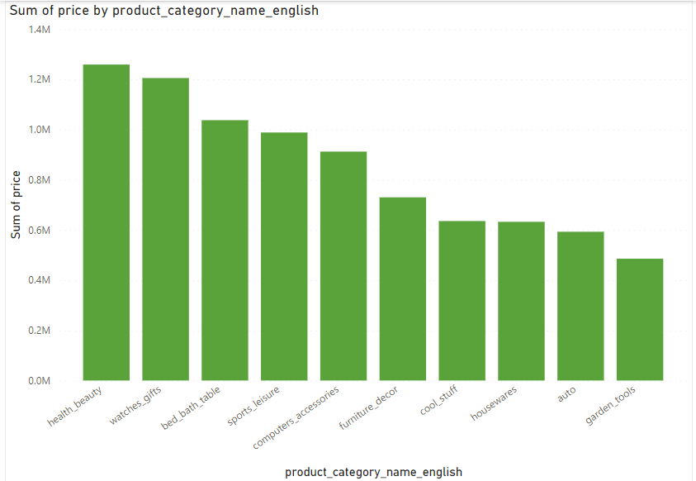

The bar chart shown represents the sum of prices for the top 10 product categories. Each bar indicates the total sales for a specific category, providing a clear comparison of revenue across these categories. The categories are ordered from highest to lowest total sales, allowing for easy identification of the most profitable categories.

Insights:

1. Health & Beauty leads as the top category, generating the highest total sales, slightly above 1.2 million.

2. Watches & Gifts closely follows, with total sales also around 1.2 million.

3. Bed, Bath & Table is the third-highest category, with sales slightly over 1 million.

4. Sports & Leisure and Computers & Accessories categories also have significant sales, each contributing close to 1 million.

5. The remaining categories, including Furniture & Decor, Cool Stuff, Housewares, Auto, and Garden Tools, show lower but still substantial sales figures.

This visualization helps in understanding which product categories are driving the most revenue, allowing for targeted marketing and inventory management strategies to maximize profitability. By focusing on the top-performing categories, the business can prioritize resources and efforts to sustain and enhance these revenue streams.

**Delayed Orders Analysis and Monthly Comparison of Delayed and On-Time Orders**

Visualization:

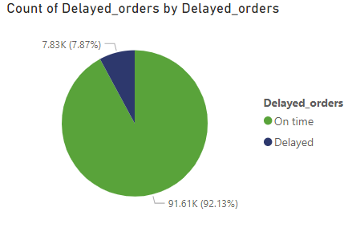

Delayed Orders: 7.83K

On-time Orders: 91.61K

* Proportion of Delayed Orders

Delayed Orders: 7.87%

On-time Orders: 92.13%

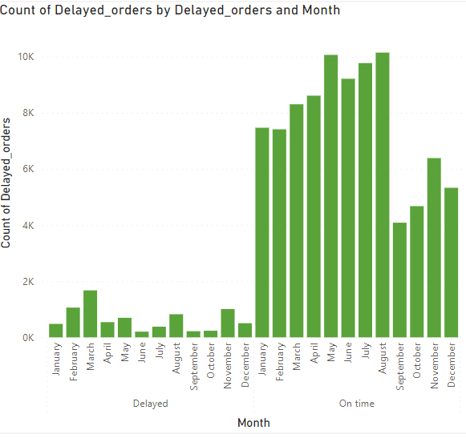

Insights:

A significant majority of orders are delivered on time, indicating an overall efficient delivery system. However, the nearly 8% delay rate could still impact customer satisfaction and requires attention.

Delays peak in the first quarter of the year, likely due to increased demand during holiday sales and post-holiday returns. Mid-year and end-of-year show a decrease in delays, suggesting better handling during these periods.

**Payment Method Analysis**

Visualization:

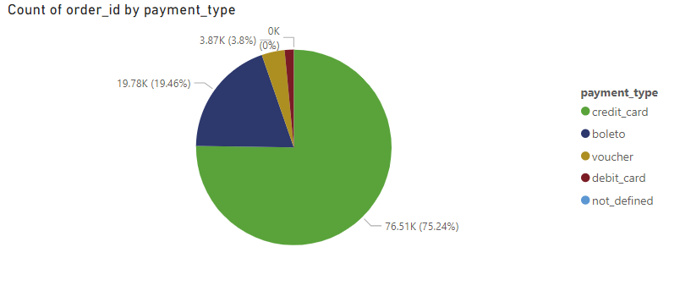

**Insights:**

Credit cards are the most frequently used payment method, with 76.51K transactions. This indicates a strong preference among customers for using credit cards for their purchases.

This suggests that after credit cards, boletos are the second most popular payment method, albeit with significantly fewer transactions.

Understanding that credit cards are the preferred method can help tailor marketing strategies. For example, offering special promotions or discounts for credit card users could further boost sales.

**Product Rating Analysis**

Visualization:

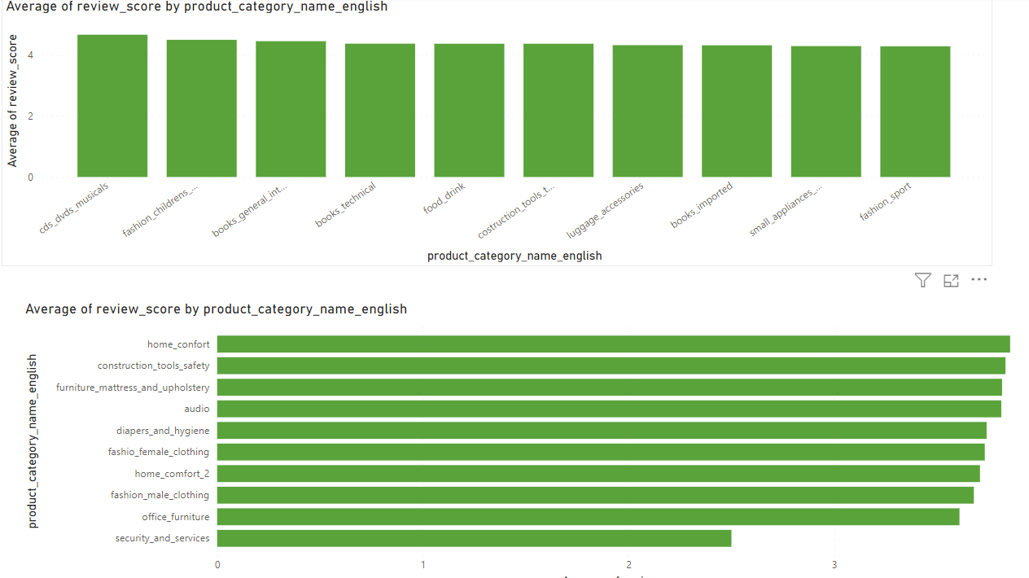

**Insights:**

**The categories such as "cds_dvds_musicals," "fashion_children's_clothes," and "books_general_interest" have relatively high average review scores, indicating that customers are generally satisfied with products in these categories.**

**For instance, if the data was collected during a holiday season, it could explain the high demand for entertainment products and children's clothes**

**The performance of these categories could also be attributed to the effectiveness of marketing strategies employed by retailers or manufacturers. Strong marketing campaigns could drive sales for certain products.**

**State-wise Sales Analysis**

Visualization:

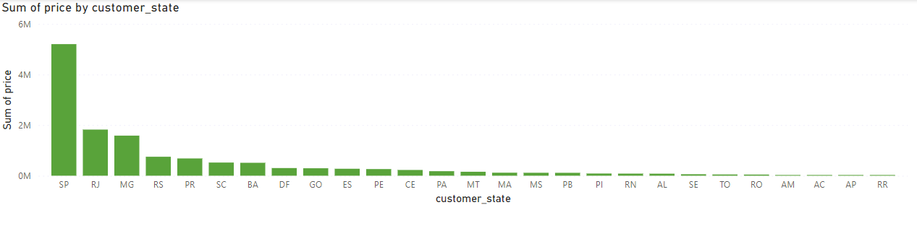

**Insights:**

Given the high sales in SP, RJ, and MG, it would be beneficial to continue investing in marketing and sales efforts in these states to maintain and potentially increase market share.

States with moderate sales like RS, PR, and SC could be targeted for growth initiatives. Tailored marketing campaigns and localized promotions could help boost sales in these regions.

For states with low sales, it would be useful to investigate the reasons behind the low performance. This could involve market research to understand local consumer preferences, potential barriers to entry, or competitive dynamics.

**Seasonal Sales Patterns**

Visualization:

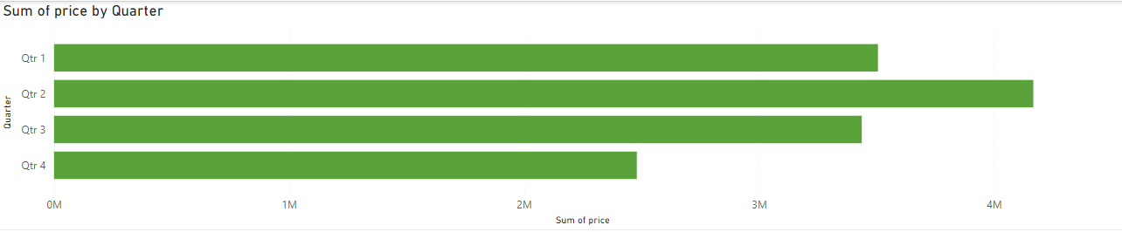

**Insights:**

Sales are relatively strong in Q1. This could be due to New Year promotions, post-holiday sales, and the beginning of the year when consumers may be making new purchases.

Sales peak in Q2, indicating a strong demand during this period. This could be driven by spring sales events, tax refunds, and the start of the summer season, which often sees increased consumer spending.

There is a slight dip in sales in Q3 compared to Q2. This period includes back-to-school shopping, but the overall sales are slightly lower than Q1 and Q2. This could be due to consumers spending more on vacations and less on retail.

Sales are the lowest in Q4, which is unusual as this period typically includes the holiday season. This could indicate potential issues such as ineffective holiday marketing campaigns, increased competition, or economic factors affecting consumer spending.

**Revenue Analysis**

Visualization:

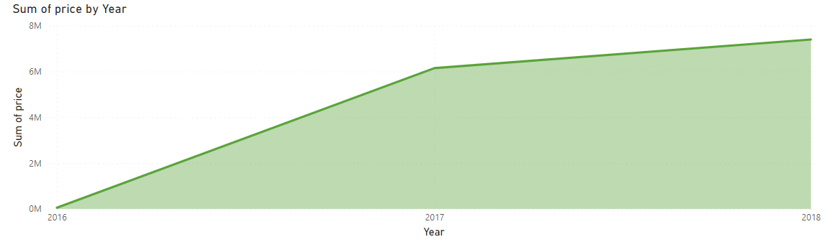

**Insights:**

The revenue in 2016 is relatively low. This could be the initial phase of the business or a period of low market penetration and brand recognition.

There is a significant increase in revenue in 2017. This dramatic growth could be due to successful marketing strategies, product launches, market expansion, or increased consumer awareness and adoption.

Revenue continues to grow in 2018, though at a slower rate compared to the previous year. This indicates sustained growth and possibly market stabilization after the rapid expansion in 2017.